**PROJECT OBJECTIVES**

* The Main Aim Of This project is to develop banking bot using artificial intelligent algorithms which should be able to analyse and understand
* Chatbots enable businesses to interact personally with customers without having to hire human personnel.
* For instance, a lot of the queries or problems that clients have have simple solutions. For this reason, businesses produce FAQs and troubleshooting manuals.
* The main goals of banking chatbots are to give consumers rapid service and increase the bank's and its staff' operational effectiveness.
* Additionally, conversational AI in banking helps the personnel spread their workload.

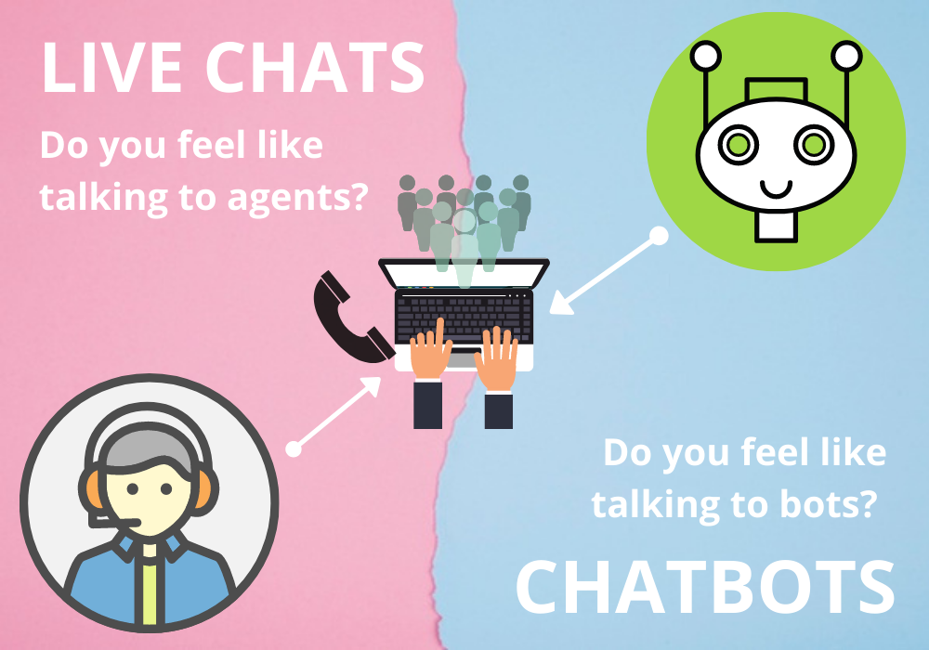

**THE MAIN OBJECTIVE OF CHATBOT**

* Businesses may connect with clients in a load via chatbots. without incurring the cost of using human representatives, in a personal way
* A chatbot system simulates a conversation with a user in natural language using messaging services, websites, mobile apps, or the phone by using conversional artificial intelligence technology.
* Chatbots increase operational effectiveness and save costs for businesses while providing convenience and extra services to both internal staff and external clients.
* They enable businesses to quickly address a variety of client concerns and issues while lowering the need for human intervention.

**THE MAIN USE OF CHATBOT**

* Teachers can now automate their time-consuming chores thanks to chatbots. while the professors keep an eye on the students' progress, the bots can respond to any questions from students about the course, assignments, or deadlines.
* Chatbots can also alter content and personalise each student's experiences.
* Chatbots can automate routine operations that need to be done at certain times.
* Customers won't have to wait while personnel are able to concentrate on more crucial responsibilities. proactive customer interaction.

**THE COMPONENTS OF A CHATBOT**

The user flow starting with intents.The NLU Engine is compsed of multiple components of chatbot

* Fetching a response
* Backend integration
* Generative models
* Retrieval-based models
* Pattern-based heuristics
* Machine learning for intent classification